[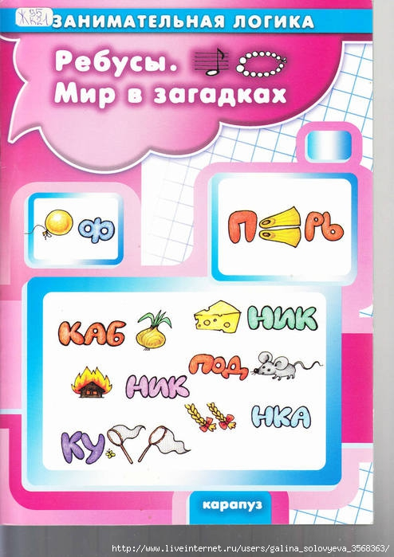](http://img1.liveinternet.ru/images/attach/c/8/100/506/100506689_large_oblozhka_0001.jpg)  
  
1.  
[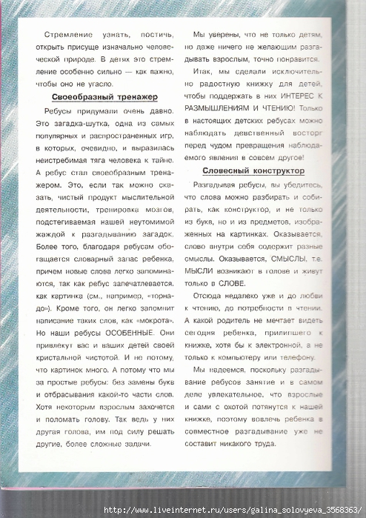](http://img1.liveinternet.ru/images/attach/c/8/100/506/100506827_large_oblozhka_0002.jpg)   
  
2.  
[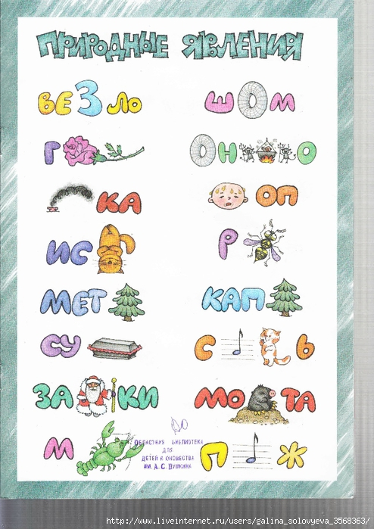](http://img0.liveinternet.ru/images/attach/c/8/100/506/100506834_large_oblozhka_0003.jpg)   
  
3.  
[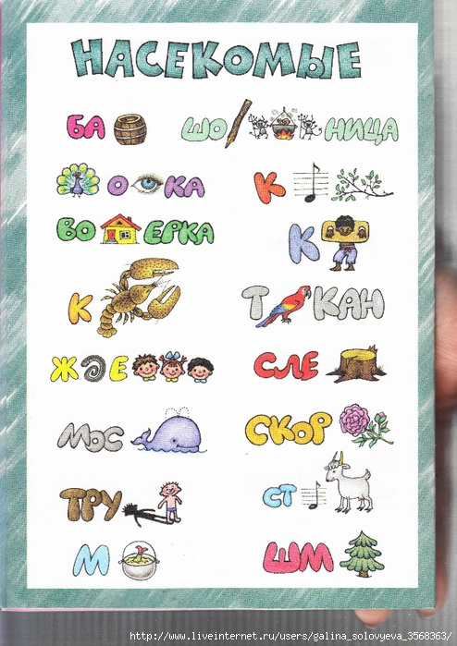](http://img0.liveinternet.ru/images/attach/c/8/100/506/100506842_large_oblozhka_0004.jpg)   
  
4.  
[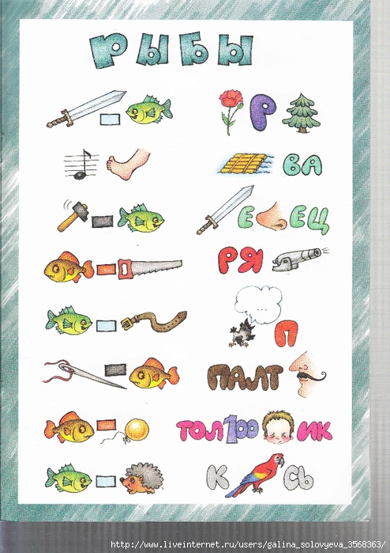](http://img0.liveinternet.ru/images/attach/c/8/100/506/100506852_large_oblozhka_0005.jpg)   
  
5.  
[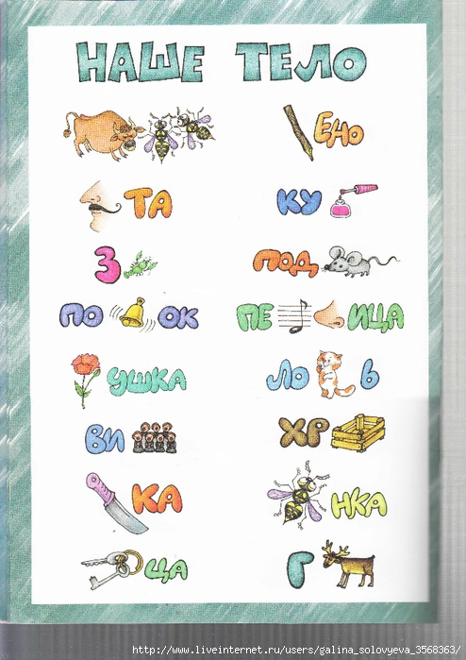](http://img1.liveinternet.ru/images/attach/c/8/100/506/100506861_large_oblozhka_0006.jpg)   
  
6.  
[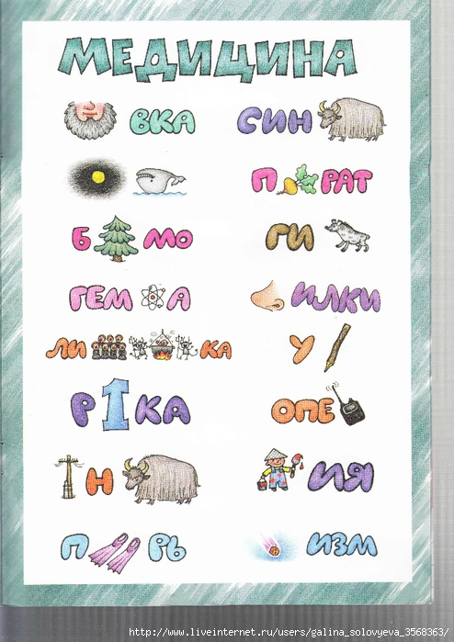](http://img1.liveinternet.ru/images/attach/c/8/100/506/100506869_large_oblozhka_0007.jpg)   
  
7.  
[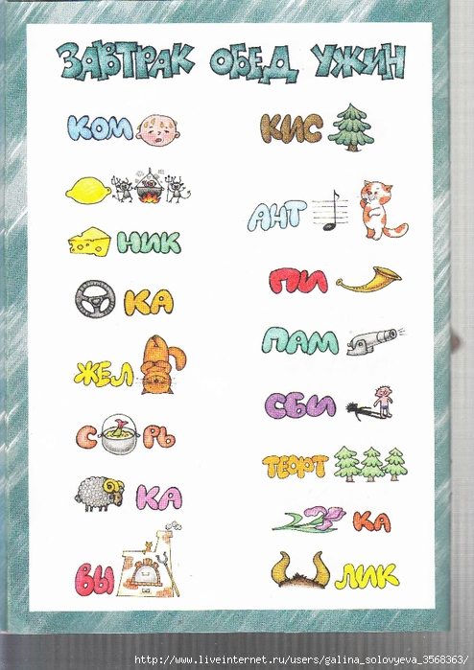](http://img1.liveinternet.ru/images/attach/c/8/100/506/100506875_large_oblozhka_0008.jpg)   
  
8.  
[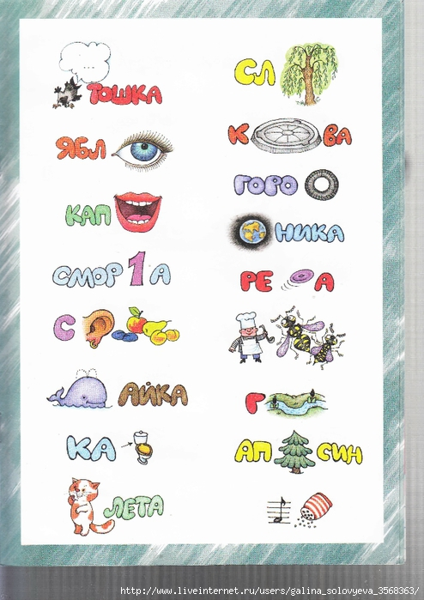](http://img1.liveinternet.ru/images/attach/c/8/100/506/100506885_large_oblozhka_0009.jpg)   
  
9.  
[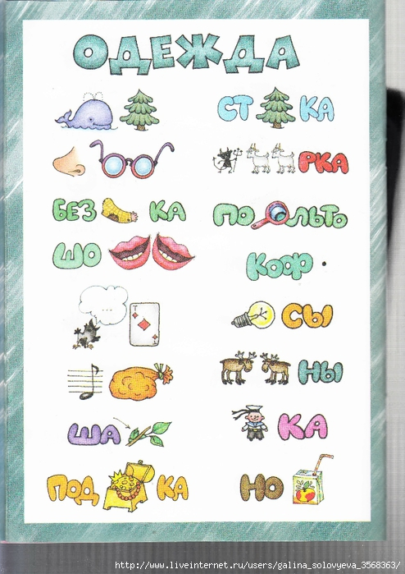](http://img1.liveinternet.ru/images/attach/c/8/100/506/100506895_large_oblozhka_0010.jpg)   
  
10.  
[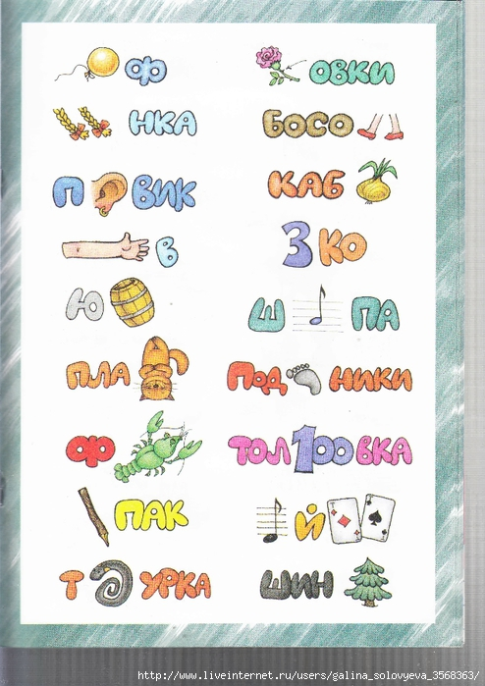](http://img0.liveinternet.ru/images/attach/c/8/100/506/100506904_large_oblozhka_0011.jpg)   
  
11.  
[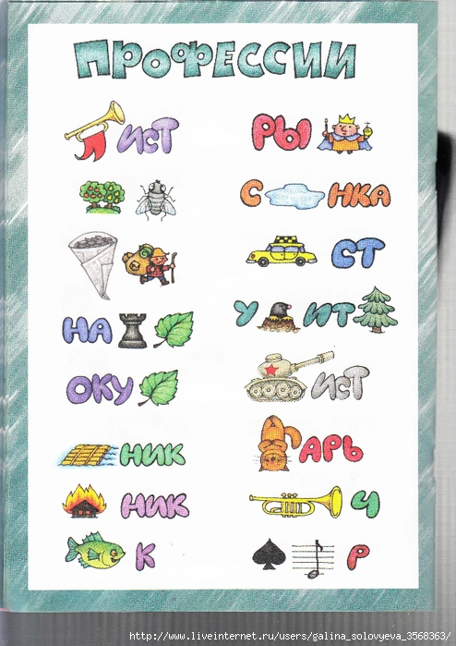](http://img0.liveinternet.ru/images/attach/c/8/100/506/100506910_large_oblozhka_0012.jpg)   
  
12.  
[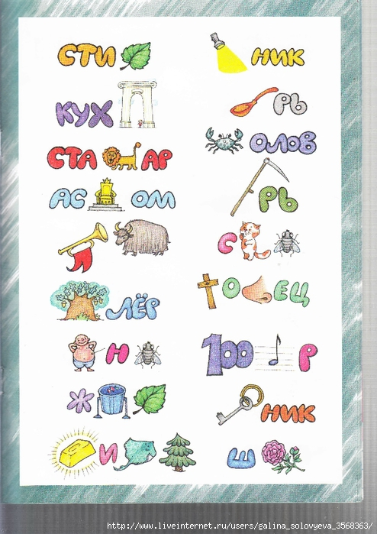](http://img0.liveinternet.ru/images/attach/c/8/100/506/100506912_large_oblozhka_0013.jpg)   
  
13.  
[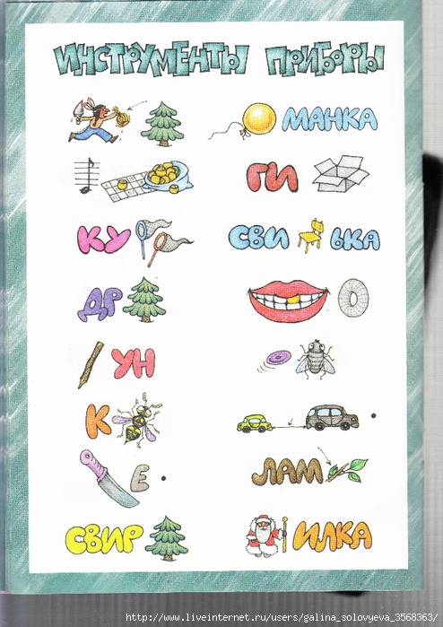](http://img1.liveinternet.ru/images/attach/c/8/100/506/100506913_large_oblozhka_0014.jpg)   
  
14.  
[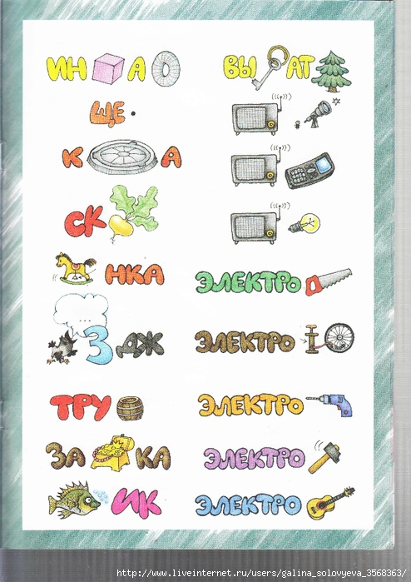](http://img1.liveinternet.ru/images/attach/c/8/100/506/100506915_large_oblozhka_0015.jpg)   
  
15.  
[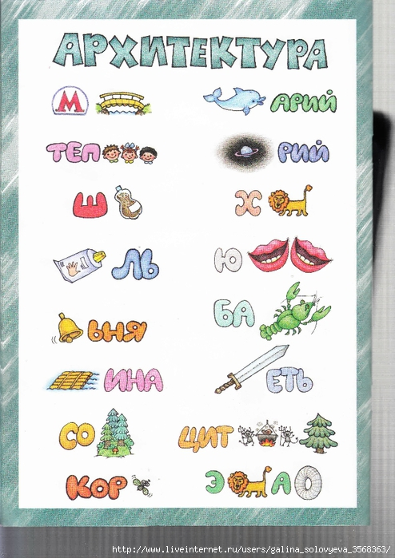](http://img1.liveinternet.ru/images/attach/c/8/100/506/100506917_large_oblozhka_0016.jpg)   
  
16.  
[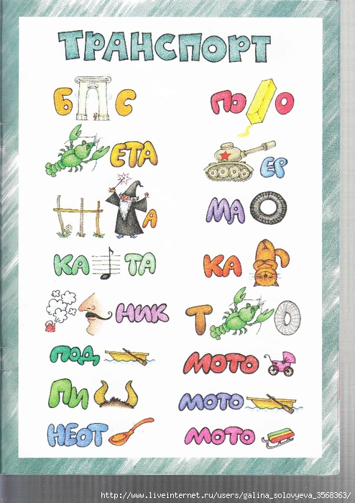](http://img0.liveinternet.ru/images/attach/c/8/100/506/100506918_large_oblozhka_0017.jpg)   
  
17.  
[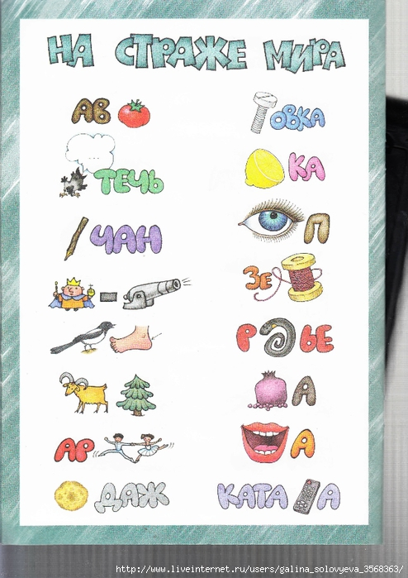](http://img1.liveinternet.ru/images/attach/c/8/100/506/100506919_large_oblozhka_0018.jpg)   
  
18.  
[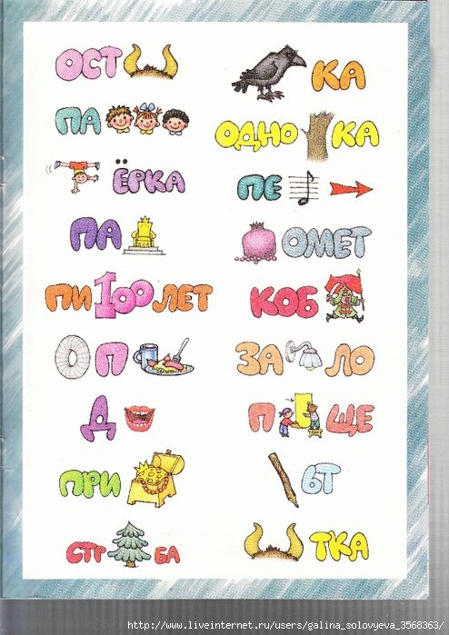](http://img0.liveinternet.ru/images/attach/c/8/100/506/100506920_large_oblozhka_0019.jpg)   
  
19.  
[[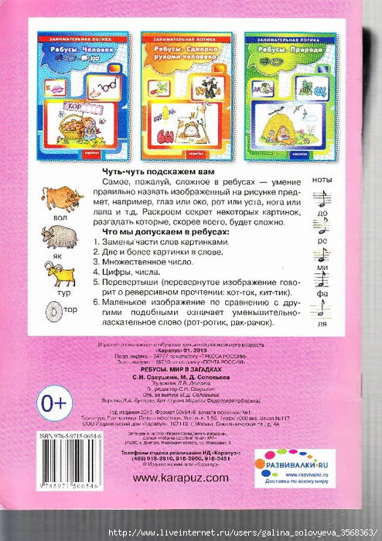](http://img1.liveinternet.ru/images/attach/c/8/100/506/100506921_large_oblozhka_0020.jpg)](http://img1.liveinternet.ru/images/attach/c/8/100/506/100506921_large_oblozhka_0020.jpg)