[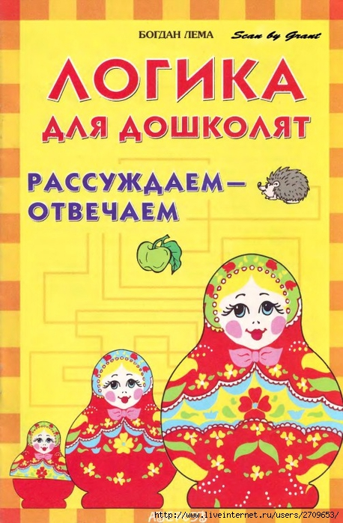](http://img1.liveinternet.ru/images/attach/c/11/115/522/115522057_large_1.jpg)

[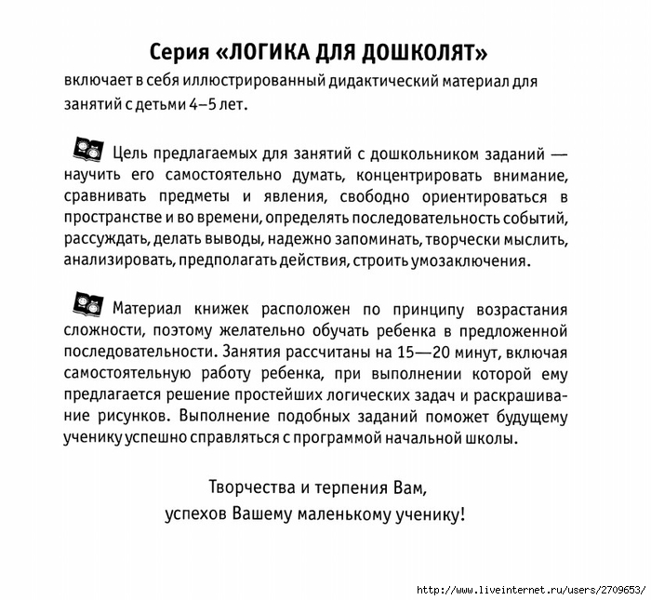](http://img0.liveinternet.ru/images/attach/c/11/115/522/115522058_large_2.jpg)  
  
  
[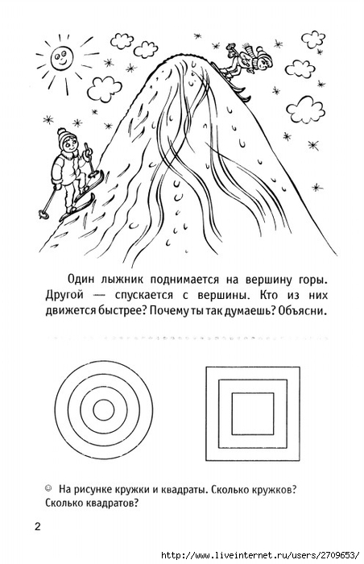](http://img1.liveinternet.ru/images/attach/c/11/115/522/115522059_large_3.jpg)  
  
  
[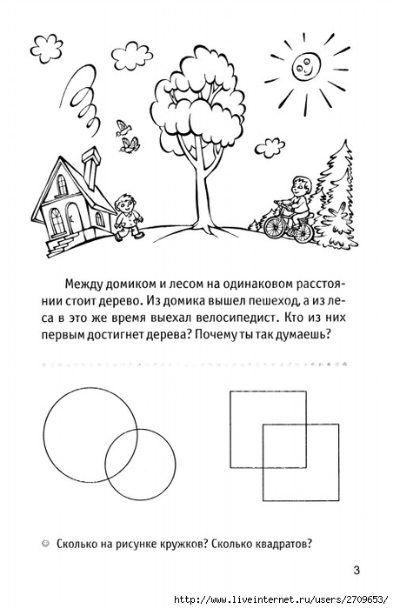](http://img0.liveinternet.ru/images/attach/c/11/115/522/115522060_large_4.jpg)  
  
  
[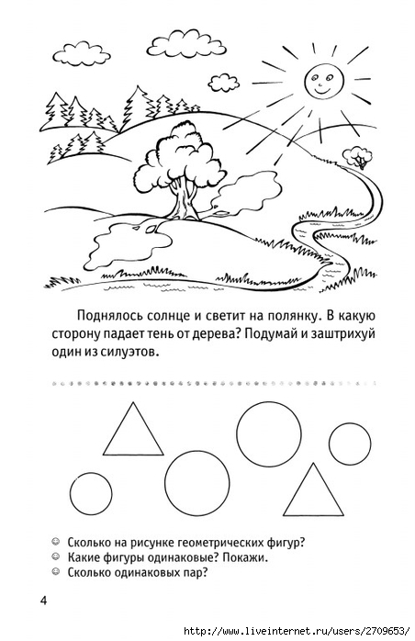](http://img0.liveinternet.ru/images/attach/c/11/115/522/115522062_large_5.jpg)  
  
  
[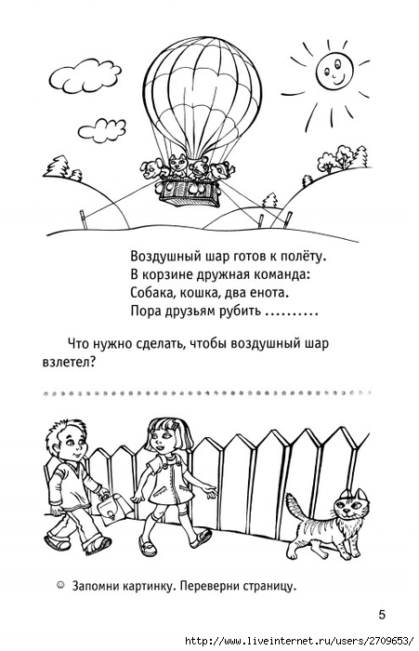](http://img1.liveinternet.ru/images/attach/c/11/115/522/115522063_large_6.jpg)  
  
  
[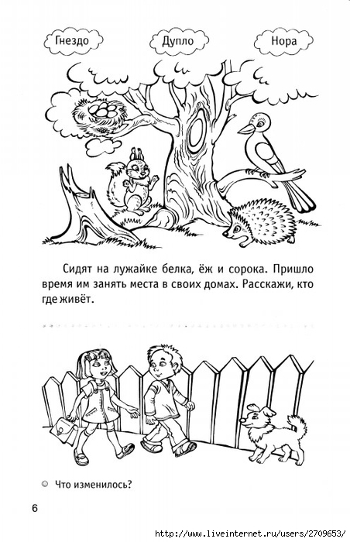](http://img0.liveinternet.ru/images/attach/c/11/115/522/115522064_large_7.jpg)  
  
  
[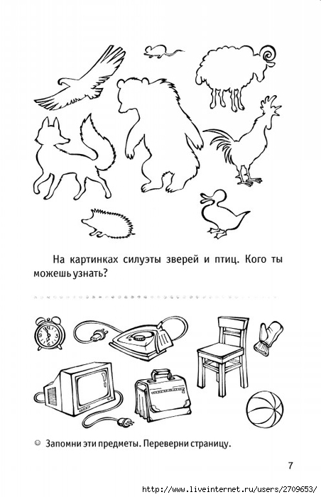](http://img1.liveinternet.ru/images/attach/c/11/115/522/115522065_large_8.jpg)  
  
  
[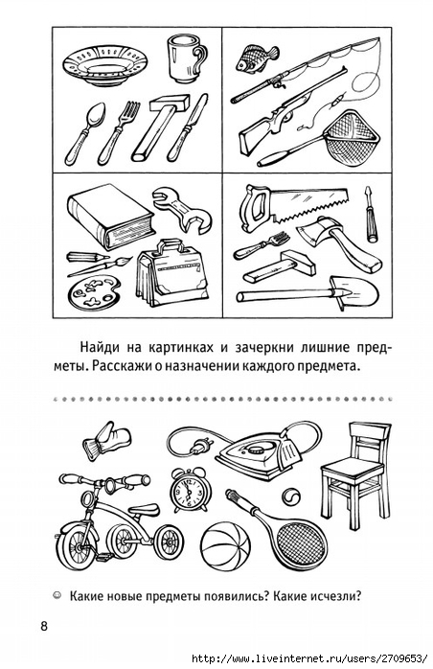](http://img0.liveinternet.ru/images/attach/c/11/115/522/115522066_large_9.jpg)  
  
  
[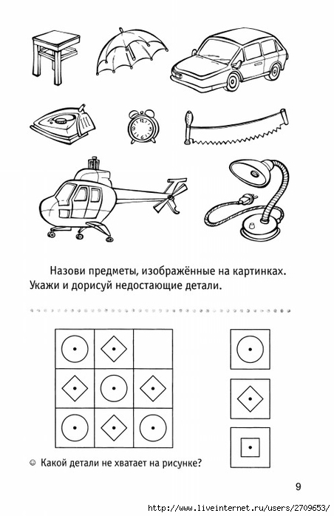](http://img1.liveinternet.ru/images/attach/c/11/115/522/115522067_large_10.jpg)  
  
  
[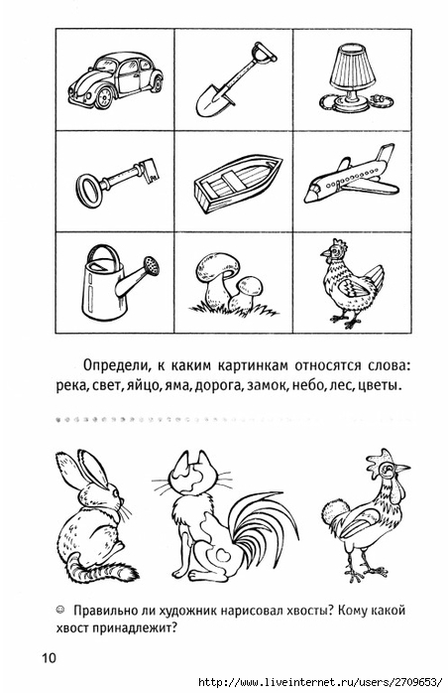](http://img0.liveinternet.ru/images/attach/c/11/115/522/115522068_large_11.jpg)  
  
  
[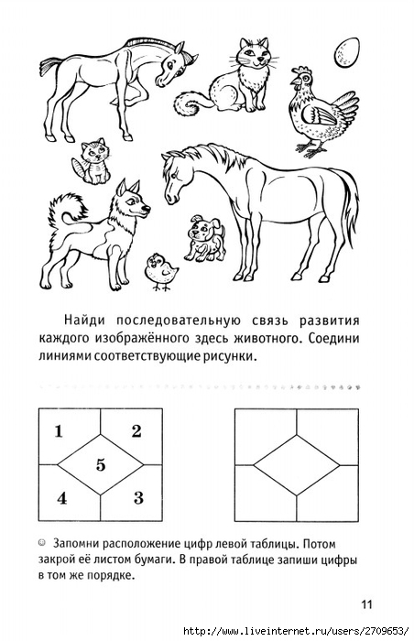](http://img1.liveinternet.ru/images/attach/c/11/115/522/115522069_large_12.jpg)  
  
  
[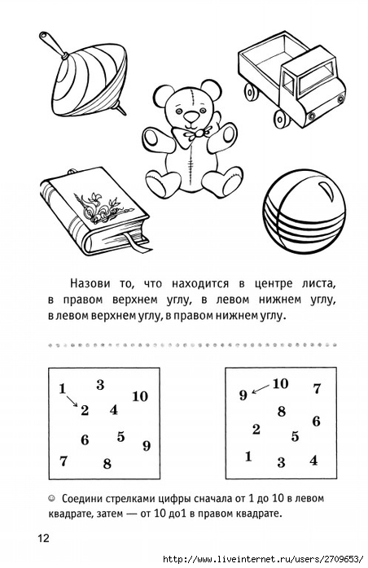](http://img0.liveinternet.ru/images/attach/c/11/115/522/115522070_large_13.jpg)  
  
  
[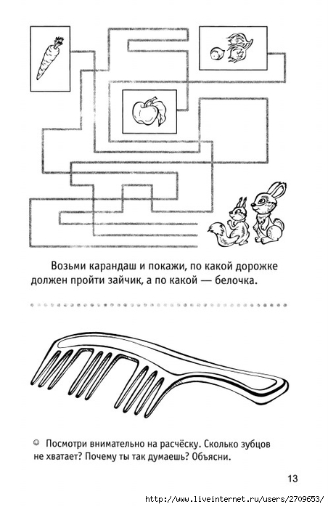](http://img1.liveinternet.ru/images/attach/c/11/115/522/115522071_large_14.jpg)  
  
  
[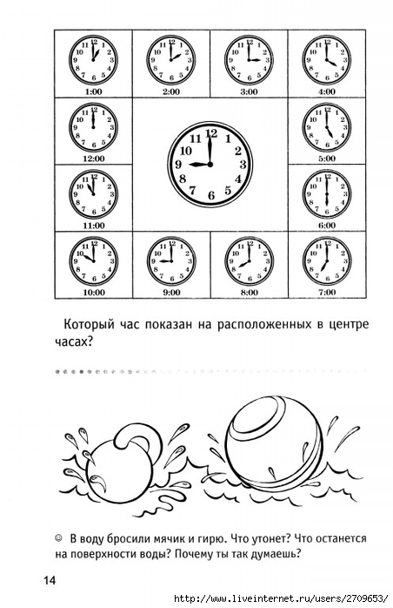](http://img0.liveinternet.ru/images/attach/c/11/115/522/115522072_large_15.jpg)  
  
  
[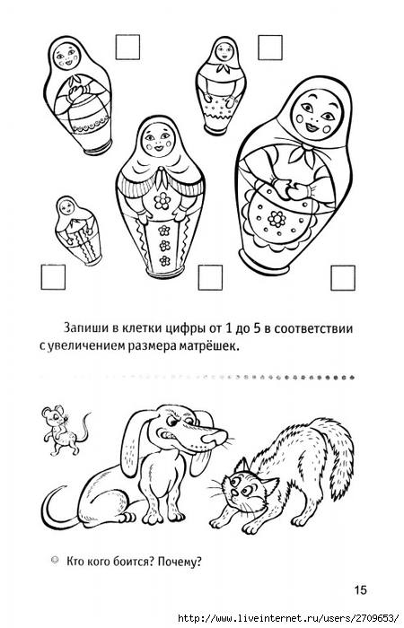](http://img1.liveinternet.ru/images/attach/c/11/115/522/115522073_large_16.jpg)  
  
  
[[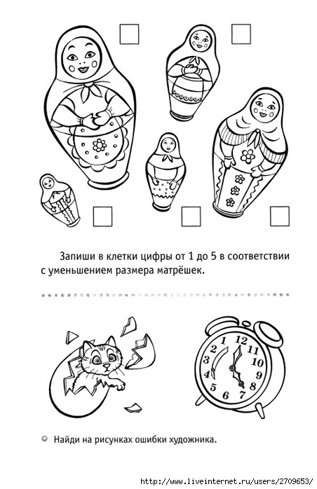](http://img1.liveinternet.ru/images/attach/c/11/115/522/115522075_large_17.jpg)](http://img1.liveinternet.ru/images/attach/c/11/115/522/115522075_large_17.jpg)